Kingdom of Saudi Arabia  Ministry of Education  Eastern Province Education Department  Tarbeat Al-Ajial International Schools  in Hafr Al-Batin |  |  |  |  |  |  | Date: ……/………/..………  Subject: Computer  Grade: G2
……………… |  | Seat Number |  | ……………………………………….. |  |  |  | Student’s Name
1st Semester Exam (1St Session) 20…./20….
Sign. | Consultative Name |  | Sign. |  | Corrector’s Name | Marks in letters |  |  | Marks  in numbers
 |  |  |  |  |  |  |  |  | 40

Q1: Match the following:
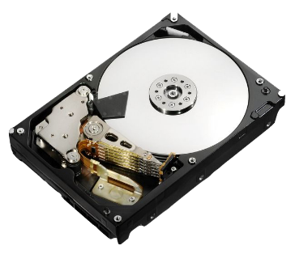 | Folder
 | Hard Disk
 | C: Drive
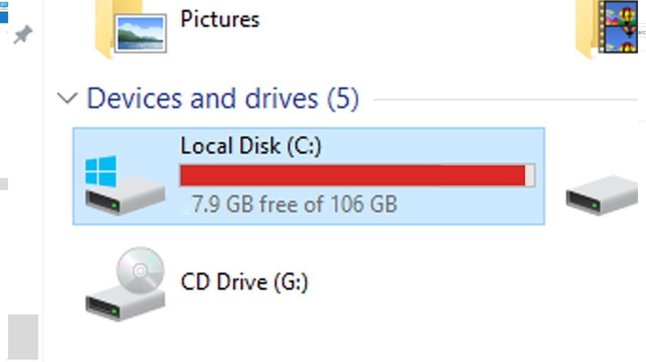 | File

Q2: Match the following:

 | Image | 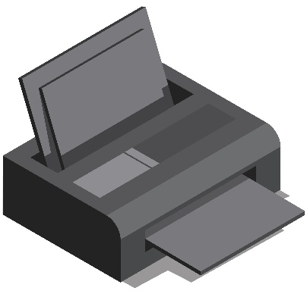 | Scanner
 | Recycle Bin |  | Mouse
 | Music | 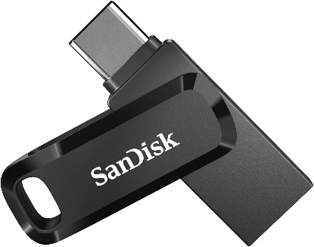 | Flash Drive
 | Alt |  | Ctrl
 | Shift | 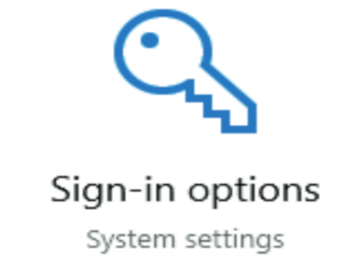 | Sign-in

Good Luck

